

Physical Inventory

QAD EE 2016

Table of Contents
Objective 3
Process Steps 3
Item Tag Delete: 3.16.23 4
Item Tag Create: 3.16.1 5
Uncounted Tag Report/Update: 3.16.15 7
Bulk Tag Create: 3.16.2 8
Tag Count Entry: 3.16.11 8
Tag Void Status Update: 3.16.7 9
Tag Report: 3.16.13 10
Counted Tag Report: 3.16.14 10
Inventory Variance Report: 3.16.18 11
Inventory Balance Update: 3.16.21 – WITHOUT AS 12
Inventory Balance Update by Pack: 3.16.3.6– WITH AS 12
Physical Inventory Transaction – 3.21.2 13

Objective

Physical Inventory is a procedure that used for annual total inventory counting. To do this special tags are used which are attached to each counted container. After counting all tags are registered in QAD to create transactions.

Process Steps
The first thing we need to do before we start the Physical Inventory is to delete all the existing/old tags in the system. For this example, I will only do the physical inventory for 1 item number.
The steps of the Physical Inventory are as follows:
- Deleting existing Item Tags (3.16.23)
- Freezing the Inventory Balance (3.16.4)
- Creating Item Tag (3.16.1)
- Setting ALL tags to Zero (3.16.15)
- Creating Bulk Tags (3.16.2)
- Tag Entries (3.16.11)
- Review Tag entries (3.16.13)
- Make used tags Void (3.16.7)
- Tag Recount Entry (3.16.12) (If needed)
- Balance Update (3.16.21) Balance Update will adjust all the stock qty’s with the values in the Tag Entries
There are various reports that can be run during the Physical Inventory process.
- Tag Report (3.16.13) each physical inventory count tag is assigned a unique tag number. The report gives an overview as to all the tags which have been created in the system
- Counted Tag Report (3.16.14) gives an overview of all the tags which have been entered during the tag entry process
- Uncounted Tag Report (3.16.15) gives an overview for all the tags which have been created but not entered during the tag entry)
- Frozen Inventory Valuation Report (3.16.16) gives an overview of the cost of the stock at the point of freezing)
- Tag Inventory Valuation Report (3.16.17) gives an overview of the cost of the stock based on what was counted & entered in the system
- Inventory Variance Report (3.16.18) shows the difference in cost between Frozen Value and Counted Value of the stock.

Item Tag Delete: 3.16.23
Before every physical inventory, we need to make sure we remove all the old/existing tags in the system. This is to ensure we always start a new physical inventory with tag 1.
Leaving the selection fields BLANK, the system will delete everything.
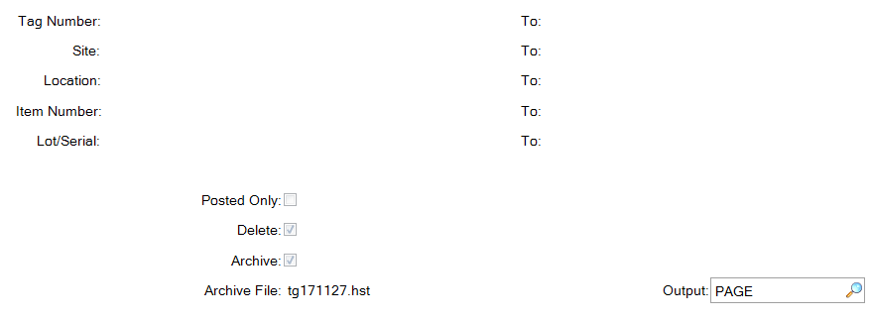
Posted Only: Specifies whether the Un-Posted tags are to be deleted. Each tag has a "Posted" flag.
- “Yes” indicates that the Inventory Balance Update has processed this tag count and used it to update the inventory balance. Inventory Balance Update only processes tags which have not yet been posted (Posted = No), and then sets these Posted flag to Yes. This prevents a tag from updating inventory balances more than once.
- “No” will remove all tags in the system.
Delete: Specifies whether to delete selected records or review without deleting.
- “Yes” Selected historical information is deleted from your database. Set Archive to Yes to copy selected information to an ASCII file (tgXXXX.hst) prior to deletion. You can reload this information later, if required, using Archive File Reload. (ask IT)
- “No” Selected records will not be deleted. However, a report listing selected records is still generated. Use this setting to review the report prior to deleting selected information.
Archive:
- “No” Selected data is not copied to an archive file.
- “Yes” Selected data is copied to an ASCII file. (tgXXXX.hst) You can reload this data later, if required, using Archive File Reload.
Inventory Balance Freeze: 3.16.4
Freezing inventory records the quantity on hand at this moment, nothing more (a screenshot of the current stock situation)
This "frozen" quantity is used by all physical inventory functions.

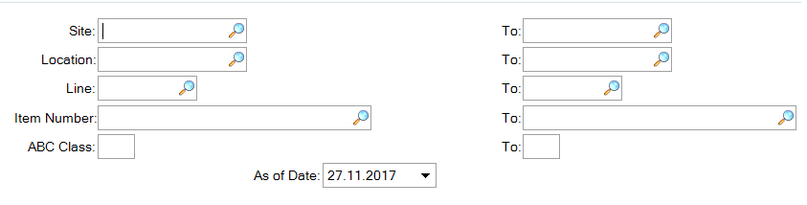
Press NEXT and confirm update with YES 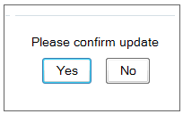

Item Tag Create: 3.16.1
Once all the Item Tags are deleted from the previous physical inventory, you have to create some new tags. For this example I will only be doing this for one item, so I will only create tags for this one item.
Starting Tag Number: States what is the first tag number to be created. When the Tag Delete was successful, this should normally start at 1.
Include Zero Quantity: Confirm whether the locations with zero quantity on hand should be counted.
- “Yes”, locations with zero quantity are selected for counting.
- “No”, these locations are not included.
Include Negative Quantity: Confirm whether the locations with negative quantity on hand should be counted.
- “Yes”, locations with negative quantity are selected for counting.
- “No”, these locations are not included.
When doing a full inventory, you will leave the selection fields BLANK.

Customer Consignment: This field has an effect only when you are using the Customer Consignment Inventory module.
Select Exclude (the default), Include, or Only to indicate how consigned inventory should display on this report or inquiry.
- Exclude displays non-consigned inventory only.
- Include displays both consigned and non-consigned inventory.
- Only displays consigned inventory only.
You do not typically include customer consigned inventory in physical inventory functions since this inventory is not actually located at your site. It is physically located at the customer site and only tracked in the system until used by the customer.

Supplier Consignment: This field has an effect only when you are using the Supplier Consignment Inventory module.
Select Exclude (the default), Include, or Only to indicate how consigned inventory should display on this report or inquiry.
- Exclude displays non-consigned inventory only.
- Include displays both consigned and non-consigned inventory.
- Only displays consigned inventory only.
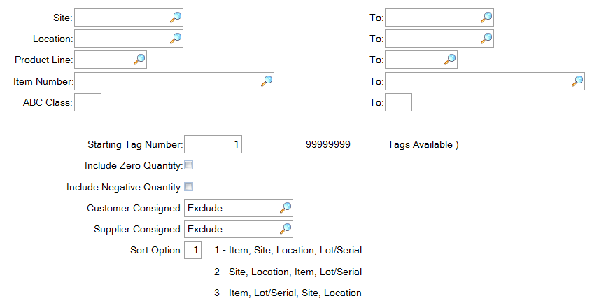
The system will display total number of tags created.
1 tag for every location where that part exists.
Once the tags are created, you can use the Tag Report (3.16.13) to check all the tags.
In the far right-hand corner, please take note of any Warnings.
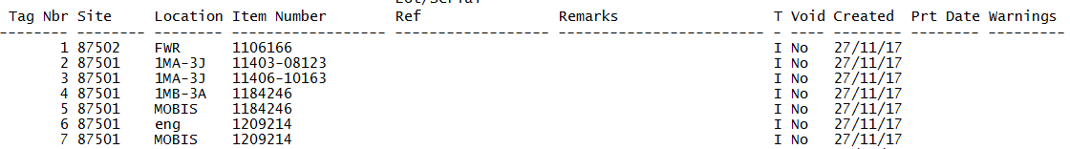
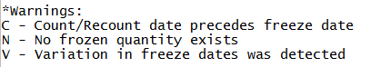

Uncounted Tag Report/Update: 3.16.15
This function specifies if the tag count on uncounted tags is to be set to ZERO.
Uncounted tags are tags which have not had an initial count entered.
Only Item Tags can be set to Zero, because when they are created, each tag number is linked to a specific Part, Location or Reference. Bulk Tags have no reference to any part/site/location, so this cannot be set.
- No - The uncounted tags are reported but not changed.
- Yes - All uncounted tags in this range are reported and their INITIAL count set to ZERO.
This is used for processing a zero-based inventory.
This is useful ONLY when all of your items may have incorrect balances. One way to zero them out is to create tags for all inventories and use this option to set the count to zero. Then, you can do your physical count and enter it using bulk tags. After the update, your inventory will be correct.
Do not use this on items under lot/serial control as you will lose your actual-bill and where-used traceability.
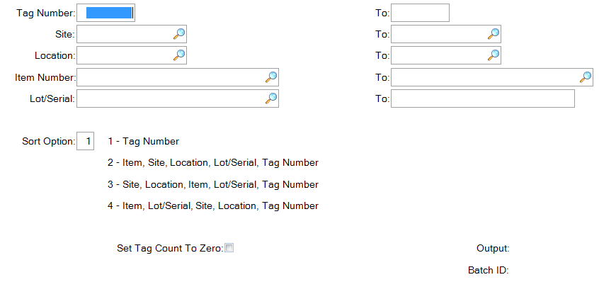

Bulk Tag Create: 3.16.2
When doing the tag entries, each item has to be entered according to the tag numbers created in QAD (Site, Location, Item Number, etc)
When doing a physical inventory, plants often purchase their own pre-printed tags from an external company. This makes it impossible to enter the tags as per the list created in, as seen in the tag report.
For this scenario, we are able to create Bulk Tags. This allows us to use the pre-printed tags purchased, and allows the Tag entry to happen according to the pre-printed tags.
This is done under menu Bulk Tag Create (3.16.2)
Starting Tag Number: This is the first available tag number after the tag create was done. In our example, we created 4 tags, so the first available tag number to create a bulk tag is 4. When you have pre-printed tags, use the starting number on these tags.
Number of Tags: The number of bulk tags to print. Bulk tags do not specify any item, site, location, etc information. The tag prints with blank spaces for each of these items. Bulk tags are used to record counts when not using the system generated tag numbers.
Make sure you create enough bulk tags for all the parts you are going to count.

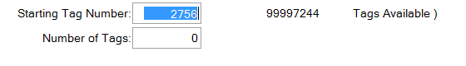

Tag Count Entry: 3.16.11
Entering the Tag Counts is similar to that of the Cycle Count Results Entry (3.13.2).
The count is entered under Tag Count (3.16.11), but if the count is “Out of Tolerance” (tolerances are defined by Central IT in Inventory Control File), a recount is needed and the item needs to be re-entered under Tag Recount Entry (3.16.12).
Tag Number: Enter the tag number
- Item Tags – Use the number generated by the system
- Bulk Tags – Use the number on the pre-printed tags
Item Number:
- Item Tags – The Item will be already filled based on your tag number.
- Bulk Tags – Enter the Item which is written in the pre-printed tag.
Site:
- Item Tags – The Site ID will be already filled based on your tag number
- Bulk Tags – Enter the Site ID which is written in the pre-printed tag
Location:
- Item Tags – The Location ID will be already filled based on your tag number
- Bulk Tags – Enter the Location ID which is written in the pre-printed tag
Qty Counted: Enter the qty counted as stated on the tag.
Date Counted: Enter the date when this count was done.
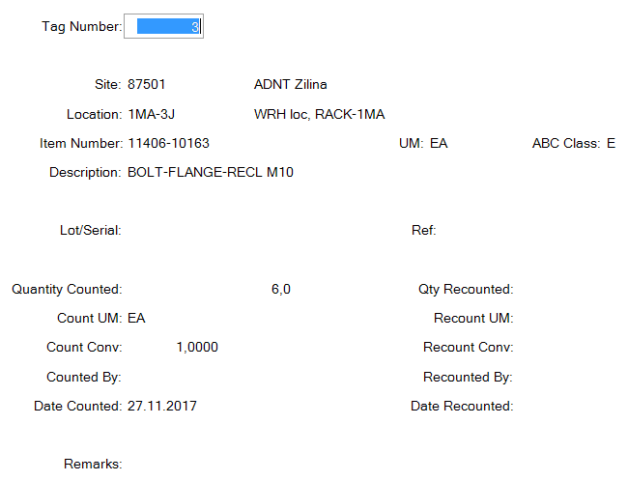

Tag Void Status Update: 3.16.7
Void tags are not considered by the Physical Inventory Update function. If a tag is damaged (and replaced with another one) or lost – it should be voided.
- YES - The status of ALL tags in the Specified Range of tags is set to Void.
- NO - Reverses the effect of a previous void. The status of all tags in the specified number range is reset to blank. Counts entered for these tags are considered by the Physical Inventory Update function.
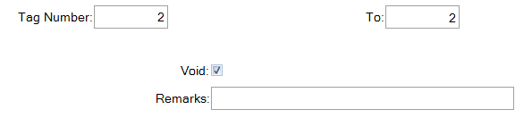

Tag Report: 3.16.13
This report displays all the tags that are currently in the system, as well giving you the status of the tags. You can run it according to your requirements by selecting the options in the appropriate fields.
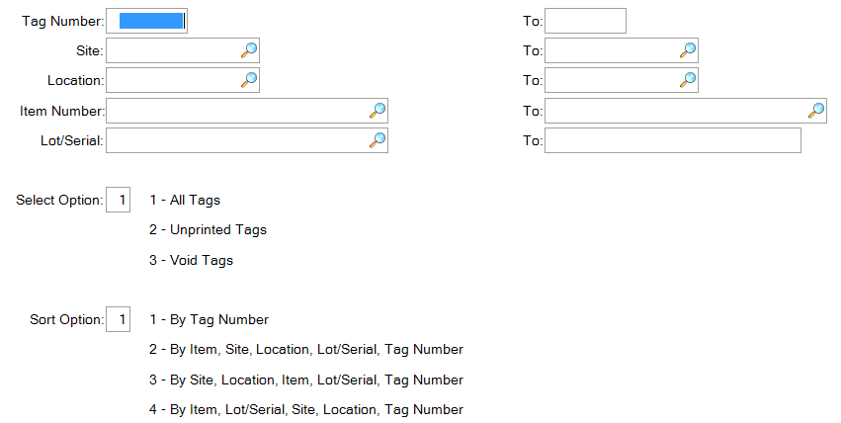

Counted Tag Report: 3.16.14
The Counted Tag Report displays the same information as the Tag Report screen. The only difference is that this report will display less data: ONLY the Tag Entries, the Qty Counted and the Count Date.
All the Tags which were set to “zero” will also be displayed on this report, with an initial count - zero.
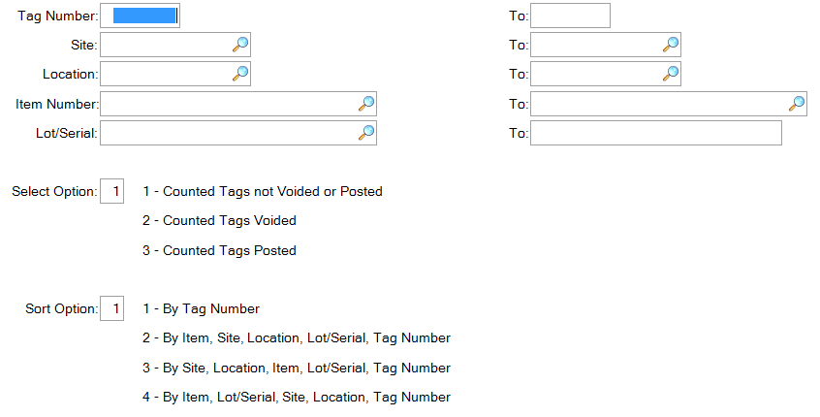

Inventory Variance Report: 3.16.18
Once all the tag entries have been done, you can run an “Inventory Variance Report”. The system will display all the parts counted where a variance has been detected.
Minimum Variance Amount: This value is compared to the minimum variance amount. Only counts with variances equal or above these tolerances appear on this report. The variance amount is calculated as count qty minus frozen qty) multiplied by item price (if a recount was entered, the recount qty is used. Otherwise the initial count qty is used)
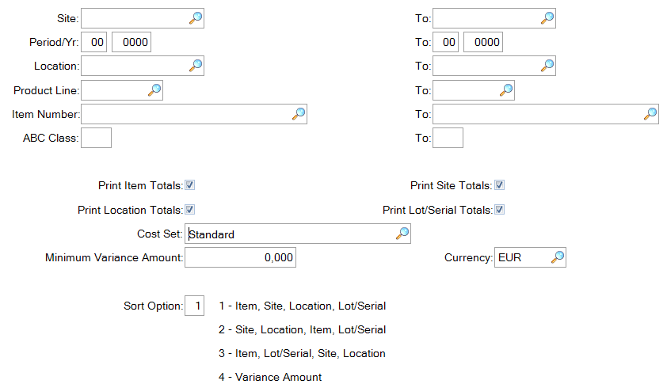
Pay attention to the “Warning” column
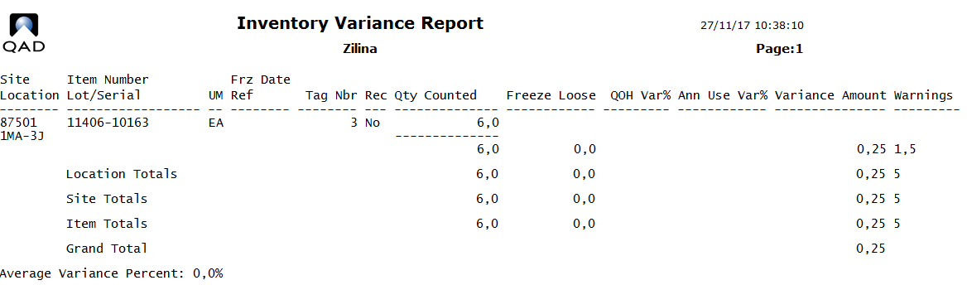
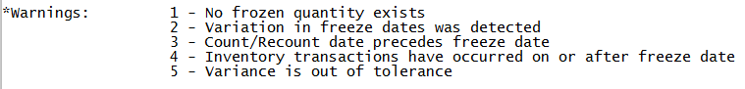

Inventory Balance Update: 3.16.21 – WITHOUT AS
When you have completed all the tag entries, and finance has run their reports, you can now update the balance to the new stock qtys. Updating the balance in QAD is done under “Inventory Balance Update” (3.16.21).
When doing the Balance Update, you have a choice to update immediately, or check first before updating.
- Update Inventory - “No”. The system shows you the report, but does not update the system.
- Update Inventory - “YES”. The system shows you the report, and UPDATES the system.

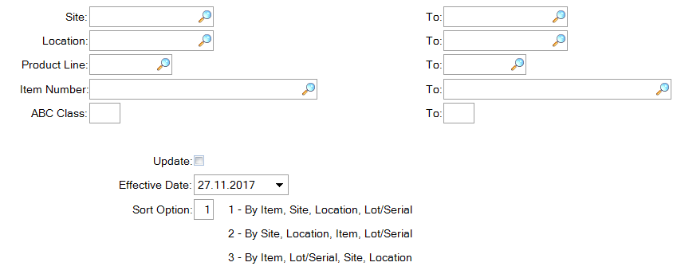

Inventory Balance Update by Pack: 3.16.3.6– WITH AS
If serialization is enabled this program must be used.
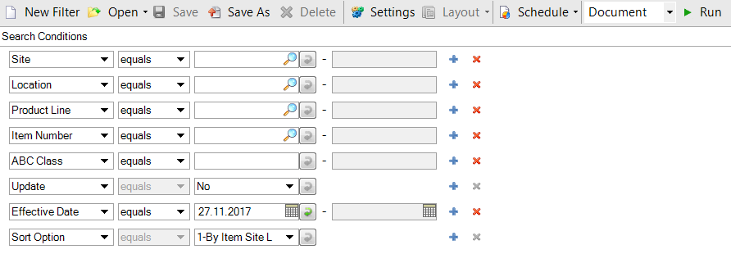

Physical Inventory Transaction – 3.21.2
Physical Inventory as well generates transactions in QAD
You can use Transactions by Item Browse to check them - 3.21.2
These transaction types are known as TAG-CNT (Tag Count) and TAG-RCNT (Tag Recount) in the system.

